## Version Control

|  |  |  |  |
| --- | --- | --- | --- |
| Date | Author | Description | Link |
| 18/10/2019 | Meraj Khan | Initial Code base | <https://bitbucket.org/ashekeenkhan/itc205-asg4/src/master/> |

## Task 1: Replication

## Script # 1: Player loses double their bet when they lose.

### Script Description

### When a player doesn’t get a match, their balance goes down by twice the amount they bet.

### Testing Requirements

This test script covers the following specific testing requirements:

* Balance should go down only by the number that was set as a bet.

### Setup

* Run main
* Select Batch Mode
* Enter “k” as for player
* Accept default for balance (100)
* Accept default for limit (10)
* Accept default for number of games (1000)
* Accept default for standard bet (10)

### Teardown

* List all steps that should be taken after the test case is executed

### Script Steps

| **Step #** | **Test Action** | **Expected Results** | **Pass/ Fail** |
| --- | --- | --- | --- |
| 1 | Select r for random pick | Prints “Starting batch mode game for k with initial balance 100, limit $10, and standard bet 10.00” | **Pass** |
| 2 | Inspect results for losing game | k bets 10 on Rooster, starting with balance $100  Rolled Gourd, Gourd, Fish  k lost 10, balance now 80 | **Fail** |

### Image 1:

### 

***After Fixing the Bug***

| **Step #** | **Test Action** | **Expected Results** | **Pass/ Fail** |
| --- | --- | --- | --- |
| 1 | Select r for random pick | Prints “Starting batch mode game for k with initial balance 100, limit $10, and standard bet 10.00” | **Pass** |
| 2 | Inspect results for losing game | k bets 10 on Prawn, starting with balance $120  Rolled Gourd, Fish, Rooster  k lost 10, balance now 110 | **Pass** |

### Test Execution

|  |  |  |  |  |
| --- | --- | --- | --- | --- |
| Date/Time | Tester | Test ID | Test Phase | Status |
| 13/10/2019 | Meraj Khan | Mkhan85 | System Cycle 1 | Failed |
| 14/10/2019 | Meraj Khan | Mkhan85 | System Cycle 2 | Passed |

## Script # 2: Player doesn’t receive any winnings

### Script Description

### Even when a player gets a match, their balance just stays the same as before they bet.

### Testing Requirements

This test script covers the following specific testing requirements:

* For each picture matches, player’s balance will increase by additional amount equal to their bet.

### Setup

* Run main
* Select Batch Mode
* Enter “k” as for player
* Accept default for balance (100)
* Accept default for limit (10)
* Accept default for number of games (1000)
* Accept default for standard bet (10)

### Teardown

* List all steps that should be taken after the test case is executed

### Script Steps

| **Step #** | **Test Action** | **Expected Results** | **Pass/ Fail** |
| --- | --- | --- | --- |
| 1 | Select r for random pick | Prints “Starting batch mode game for k with initial balance 100, limit $10, and standard bet 10.00” | **Pass** |
| 2 | Inspect results for winning game | k bets 10 on Gourd, starting with balance $60  Rolled Gourd, Gourd, Fish  k won 20, balance now 60 | **Fail** |

### Image 2:

### 

***After Fixing the Bug***

| **Step #** | **Test Action** | **Expected Results** | **Pass/ Fail** |
| --- | --- | --- | --- |
| 1 | Select r for random pick | Prints “Starting batch mode game for k with initial balance 100, limit $10, and standard bet 10.00” | **Pass** |
| 2 | Inspect results for winning game | k bets 10 on Gourd, starting with balance $60  Rolled Gourd, Gourd, Fish  k won 20, balance now 60 | **Fail** |

***After Fixing the Bug***

| **Step #** | **Test Action** | **Expected Results** | **Pass/ Fail** |
| --- | --- | --- | --- |
| 1 | Select r for random pick | Prints “Starting batch mode game for k with initial balance 100, limit $10, and standard bet 10.00” | **Pass** |
| 2 | Inspect results for winning game | k bets 10 on Rooster, starting with balance $110  Rolled Gourd, Fish, Rooster  k won 10, balance now 120 | **Pass** |

### Test Execution

|  |  |  |  |  |
| --- | --- | --- | --- | --- |
| Date/Time | Tester | Test ID | Test Phase | Status |
| 13/10/2019 | Meraj Khan | Mkhan85 | System Cycle 1 | Failed |
| 14/10/2019 | Meraj Khan | Mkhan85 | System Cycle 2 | Passed |

## Script # 3: Player cannot reach betting limit

### Script Description

### Even when a placing bet would only take a player to their betting limit, the bet cannot be placed.

### Testing Requirements

This test script covers the following specific testing requirements:

* Player should be able to place a bet even if it takes the player to their betting limit.

### Setup

* Run main
* Select Batch Mode
* Enter “k” as for player
* Accept default for balance (100)
* Accept default for limit (10)
* Accept default for number of games (1000)
* Accept default for standard bet (10)

### Teardown

* List all steps that should be taken after the test case is executed

### Script Steps

| **Step #** | **Test Action** | **Expected Results** | **Pass/ Fail** |
| --- | --- | --- | --- |
| 1 | Select r for random pick | Prints “Starting batch mode game for k with initial balance 100, limit $10, and standard bet 10.00” | **Pass** |
| 2 | Inspect results for reaching betting limit | k bets 10 on Rooster, starting k bets 10 on Rooster, starting with balance $40  Rolled Gourd, Gourd, Fish  k lost 10, balance now 20  Player leaves game with $20 after 7 rounds, having started with $100 | **Fail** |

### Image 3:

### 

***After Fixing the Bug***

| **Step #** | **Test Action** | **Expected Results** | **Pass/ Fail** |
| --- | --- | --- | --- |
| 1 | Select r for random pick | Starting batch mode game for k with initial balance 100, limit $90, and standard bet 10.00 | **Pass** |
| 2 | Inspect results for reaching betting limit | Starting batch mode game for k with initial balance 100, limit $90, and standard bet 10.00  k bets 10 on Fish, starting with balance $100  Rolled Rooster, Gourd, Crab  k lost 10, balance now 90  Player leaves game with $90 after 1 rounds, having started with $100 | **Pass** |

### Test Execution

|  |  |  |  |  |
| --- | --- | --- | --- | --- |
| Date/Time | Tester | Test ID | Test Phase | Status |
| 13/10/2019 | Meraj Khan | Mkhan85 | System Cycle 1 | Failed |
| 14/10/2019 | Meraj Khan | Mkhan85 | System Cycle 2 | Passed |

## Script # 4: Odds in the game are incorrect

### Script Description

### The win: (win + lose) ratio might have been better expressed as the (number of winning rounds): (total number of rounds) ratio. That ratio should be very nearly equal to 0.42.

### Testing Requirements

This test script covers the following specific testing requirements:

### The game should have an approximate win: (win + lose) ratio very close to 0.42 (error < 0.01 over 10000 games).

### Setup

* Modified code to add counter for Total wins in batch mode game and calculate winning ratio
* Run main
* Select Batch Mode
* Enter “k” as for player
* Accept default for balance (10000)
* Accept default for limit (10)
* Accept default for number of games (1000)
* Accept default for standard bet (10)

### Teardown

* List all steps that should be taken after the test case is executed

### Script Steps

| **Step #** | **Test Action** | **Expected Results** | **Pass/ Fail** |
| --- | --- | --- | --- |
| 1 | Select r for random pick | Prints “Starting batch mode game for k with initial balance 10000, limit $10, and standard bet 10.00” | **Pass** |
| 2 | Inspect results for winning ratio | Player leaves game with $2360 after 1000 rounds, having started with $10000  Total Wins 618  Total loses 382  The winning ratio is 0.618 | **Fail** |

### Image 4:

### 

***After Fixing the Bug***

| **Step #** | **Test Action** | **Expected Results** | **Pass/ Fail** |
| --- | --- | --- | --- |
| 1 | Select r for random pick | Prints “Starting batch mode game for k with initial balance 10000, limit $10, and standard bet 10.00” | **Pass** |
| 2 | Inspect results for winning ratio | Player leaves game with $2360 after 1000 rounds, having started with $10000  Total Wins 618  Total loses 382  The winning ratio is 0.618 | **Fail** |

### Test Execution

|  |  |  |  |  |
| --- | --- | --- | --- | --- |
| Date/Time | Tester | Test ID | Test Phase | Status |
| 14/10/2019 | Meraj Khan | Mkhan85 | System Cycle 1 | Failed |
| 13/10/2019 | Meraj Khan | Mkhan85 | System Cycle 2 | Failed |

## Task 2: Simplification

## Task 3: Tracing

|  |  |
| --- | --- |
| Bug name: | Player loses double their bet when they lose. |
| Description: | When a player doesn’t get a match, their balance goes down by twice the amount they bet. |
| Point of Failure: | At line 80 in BatchModeGame.java, punter.getBalance() value is incorrect. |
| Hypothesis: | punter.getBalance() is reporting balance incorrectly. Once the betting amount is deducted from the balance, the remaining balance is set as the value for current balance. However, after losing the bet the betting amount is deducted from the current balance instead of initial balance. As a result, the balance is going down by twice the betting amount. |
| Screenshot: |  |
| Test: | Set a breakpoint at line 95, visually inspect punter.getBalance() value in line 79 before output. |
| Result: | punter.getBalance() value is reported incorrectly. |

|  |  |
| --- | --- |
| Bug name: | Player doesn’t receive any winnings. |
| Description: | Even when a player gets a match, their balance just stays the same as before they bet. |
| Point of Failure: | At line 75 in BatchModeGame.java, punter.getBalance() value is incorrect as it is not including the winning amount |
| Hypothesis: | At line 75, punter.getBalance() is reporting balance incorrectly as it is not including the winning amount. |
| Screenshot: |  |
| Test: | Set a breakpoint at line 95, visually inspect punter.getBalance() value in line 75 before output. |
| Result: | punter.getBalance() value is reported incorrectly. |

|  |  |
| --- | --- |
| Bug name: | Player cannot reach betting limit |
| Description: | Even when a placing bet would only take a player to their betting limit, the bet cannot be placed. |
| Point of Failure: | At line 68 in Punter.java, balanceExceedsLimitBy method is constructed with an error. |
| Hypothesis: | Method balanceExceedsLimitBy is not constructed correctly. It is set to accept value only greater than the betting limit. |
| Screenshot: |  |
| Test: | Set a breakpoint at line 68 in Punter.java, visually inspect method output. |
| Result: | Batch mode game failed to play as the placing the default bet amount ($10) would go below limit ($90). |

|  |  |
| --- | --- |
| Bug name: | Odds in the game are incorrect. |
| Description: | The game should have an approximate win: (win + lose) ratio very close to 0.42 (error < 0.01 over 10000 games) |
| Point of Failure: | At line 35 in Face.java, **int** rand = *random*.nextInt(len) is not generating face index number in a way to generate 0.42 to winning ratio. |
| Hypothesis: | Method **public** **static** Face getRandom() is not gerating the winning ration of 0.42 |
| Screenshot: |  |
| Test Result: | Method **public** **static** Face getRandom() has incorrect winning ration (0.61) as shown in image below – |

## Task 2: Resolution

**Bug 1 - Player loses double their bet when they lose.**

|  |  |
| --- | --- |
| **Output before fixing the Bug** |  |
| **Output after fixing the Bug** |  |

**Bug 2 - Player doesn’t receive any winnings.**

|  |  |
| --- | --- |
| **Output before fixing the Bug** |  |
| **Output after fixing the Bug** |  |

**Bug 3 - Player cannot reach betting limit**

|  |  |
| --- | --- |
| **Output before fixing the Bug** |  |
| **Output after fixing the Bug** |  |

Code fixes

1. Updated code in src/InteractiveGame.java

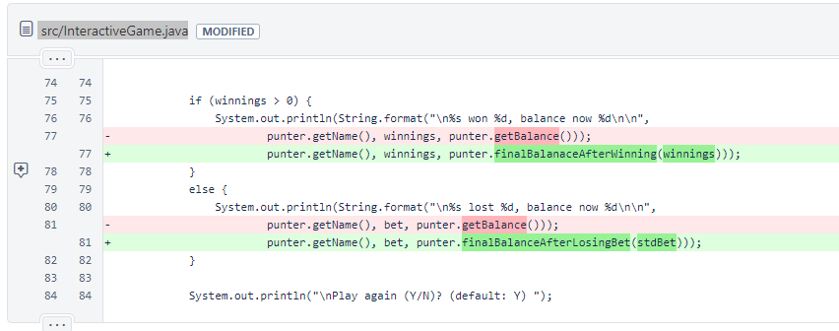

2. Updated code in src/Punter.java

### Image 1 of 2:

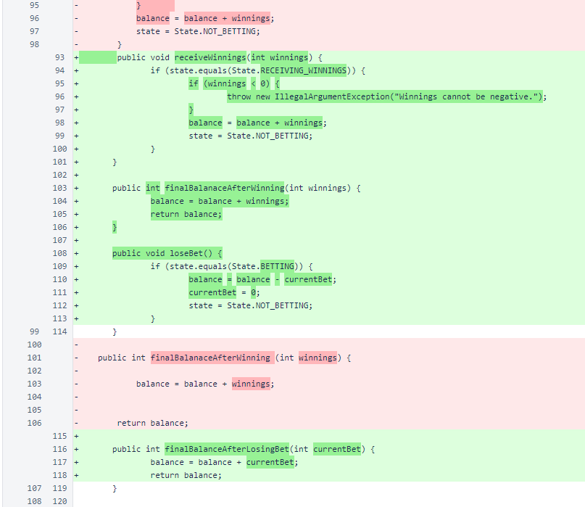

### Image 2 of 2:

